September 2, 2014
Dear Junior Kindergarten Families,

Assalamu Alaikum wa Rahmutullahi wa Barakatuhu!
May this letter find you and your loved ones in the best of health and Iman.

We would like to welcome you and your child to Junior Kindergarten 1 at Islamic Foundation School! We are very honoured and excited to have your child in our class this year. Kindergarten is exciting for all children as it is the stepping stone towards their education.

It is our pledge to keep you informed of your child’s progress from time to time as we feel that close communication between home and school is of utmost importance in a child’s development. With your assistance, we can be partners in your child’s bright future, Insha Allah. We will send monthly newsletters containing important information about your child’s progress, upcoming events as well as monthly calendar. Please post this letter some place visible to you as it will remind you of coming events and activities (i.e. on you fridge door). Our goal for this letter is to be an extension for our classroom to involve parents in learning, activities and academic progress of their children.

Our teaching begins with making your child feel at home in our classroom. We have gone to great lengths to make our classroom a comfortable and welcoming place that will facilitate a safe and secure feeling to ensure academic success.

We encourage you to contact us if you have any questions or concerns at any time. You can write us a note, call the school office for a message, or email us at Ifsjk1@yahoo.ca. You can also visit our website at http://myifs.ca/en/# . For individual concerns, we will contact you by phone or send a note home. We have attached some important information to start off the year on this letter, please read it carefully. We are looking forward to a wonderful and exciting year with you and your child!
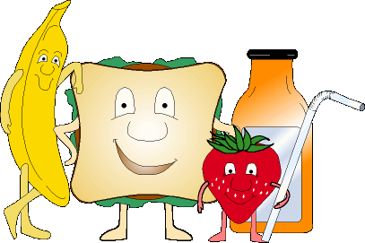
Healthy eating!
Please make sure your child brings healthy lunch. Snacks and lunch must contribute to child’s daily nutritional needs. It should be low in sugar to help prevent dental decay. Offering children a wide assortment of foods will help them set a wide variety of vitamins and minerals. Healthy eating patterns are essential for students to achieve their full academic potential, full physical and mental growth and lifelong health and wellbeing. We would like to make our classroom environment friendly and therefore we would request all the parents to send all the lunch and juice in recyclable plastic container only that can be used every day (no disposable juice boxes or bags).This will help us in minimizing the garbage and help our school go green!
Communication
Every Friday your child will take home his/her homework folder. Please ensure to check this each time. It may contain important announcements, homework assignments, or completed work. It is very important that your child brings this back to school the following Monday. This will help to create a routine and continue the communication between home and school.
Reading Development and Enhancement
These first weeks of school we will be getting to know one another. Creating community is a large part of the beginning of a new school year. Each day we will have a Student Leader. Student Leaders will bring one snack item to share with the rest of the class. Please make sure that the snack sent to school is healthy and nut free. We will not serve the snacks if it contains any haram ingredients or traces of nuts in it. The Student Leader may also bring one toy or a book for Show and Tell and share with the rest of the class. The Student Leader will be helping the teacher with large group/circle time activity such as doing the morning message board, working with word wall etc. This will help them to become successful, independent writers and help them in reading readiness and communication skills.
Reviews
Homework will require some parental involvement at this level. Your cooperation is essential in developing a positive homework habit. First and foremost, you can encourage your child by showing interest and demonstrating helpful attitudes toward homework. Provide a noise-free, well-lit place to work. Encourage your child to ask for help when he/she doesn't understand something or is frustrated. Teachers, like parents, can help only if they know there is a need. Decide if it becomes too frustrating of a task to stop and take a break. Any work done under stress or frustration is not a positive or healthy learning experience.

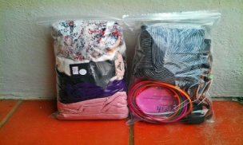 Clothes & Toys
Please send a complete change of clothes (shirt, pants, underpants, and socks) placed in a large zip lock bag labeled with student’s first and last name. Any other toys and personal valuables should not be brought to school as the school will not be responsible if they are lost. All personal belongings should be clearly labeled with your child’s name.
Please do not hesitate to contact us with any questions or concerns and Insha Allah we will try our level best to work with every individual need.

Sr. Tabassum jabbar and Sr. Farzana balapatel.

